According to Charles’s Law:
A. $\frac{V_{1}}{T_{1}}=\frac{V_{2}}{T_{2}}$
B. $\frac{V_{1}}{T_{1}}=\frac{T_{2}}{V_{2}}$
C. $V∝\frac{1}{P}$
D. $V∝n$
ANSWER: A
Which graph represents Absolute zero?
A. 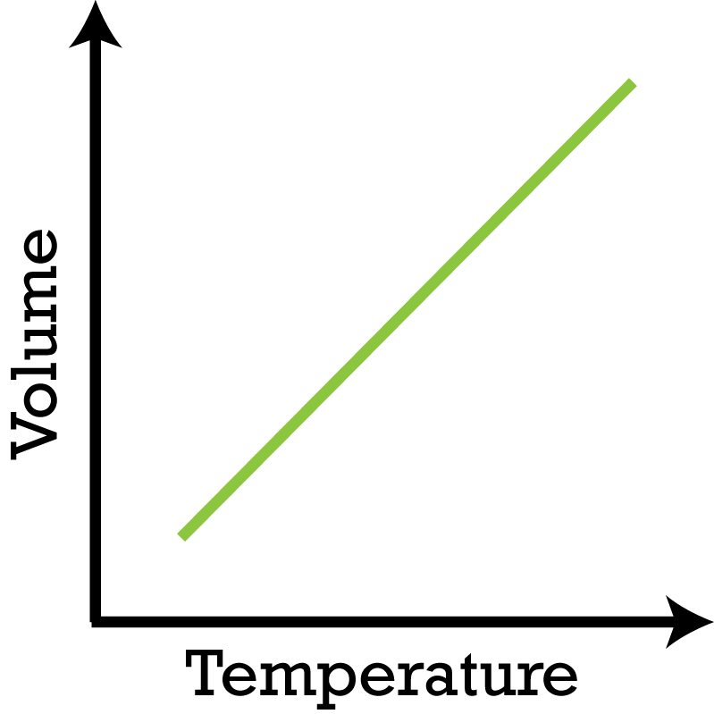
B. 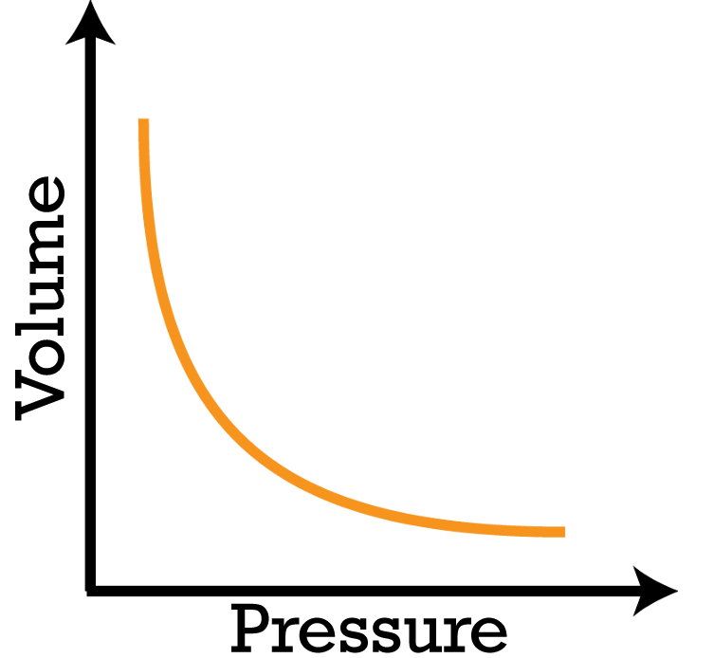
C. 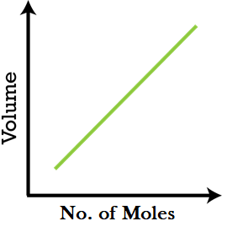
D. 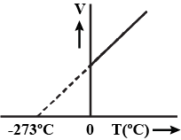
ANSWER: D
To prove Charles’s Law, temperature is taken in
A. High temperature
B. Fahrenheit scale
C. Kelvin scale
D. Centigrade scale
ANSWER: C
Which of the following is equal to absolute zero?
A. $-273K$
B. $-273℃$
C. $0℃$
D. None of these
ANSWER: B
Which is valid at absolute zero Temperature?
A. Kinetic energy of molecules ceased
B. Kinetic energy of molecules increased
C. Volume increases
D. None of these
ANSWER: A
At absolute zero temperature (0 K), which is false statement according to Charles’s Law?
A. At -273$℃$ the volume of a given mass of a gas reduces to zero
B. The absolute zero is represent in volume-temperature graph
C. Molecules motion stop at absolute zero
D. None of these
ANSWER: D
If the line of the graph obtained from Charles’s law is extra plotted it intersects the temperature axis at
A. 273$℃$
B. -273$℃$
C. 273.16$℃$
D. -273.16$℃$
ANSWER: D

The straight line in Charles’s Law graph is known as:
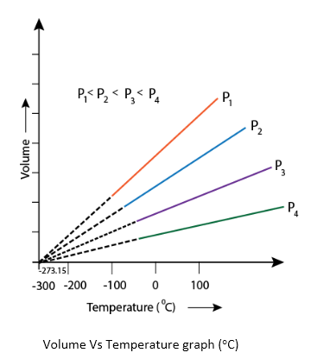
A. Isotherm
B. Isobar
C. Isochoric
D. Parabola curve
ANSWER: B
The absolute zero temperature is discovered by the:
A. Boyle’s Law
B. Charles’s Law
C. Avogadro’s Law
D. Graham’s Law
ANSWER: B
The absolute zero is
A. Hypothetical temperature
B. Volume of a gas reduces to zero
C. -273.15$℃$
D. All of these
ANSWER: D
What is the correct reason to explain the misconception of absolute zero?
A. At absolute zero temperature the volume become zero because the volume of matter cannot be reduced to zero
B. At absolute zero temperature the volume become zero because gases liquefy or solidify before reaching out to absolute zero temperature
C. Lowest possible temperature
D. Both A & B
ANSWER: D

According to the kinetic theory of gas, at which temperature the kinetic energy of a molecule of an ideal gas becomes zero?
A. $- 273℃$
B. 0$℃$
C. $–100℃$
D. $273 K$
ANSWER: A
Which Scientist discovered the absolute scale of temperature?
A. Charles
B. Boyle
C. Kelvin
D. Gay-Lussac
ANSWER: C
The nature of the V-t (t in Celsius scale) graph in Charlee’s law is-
A. Straight line
B. Circle
C. Parabola
D. Hyperbola
ANSWER: A
If the temperature is increased from $0℃$ to $30℃$at a constant pressure of gas having fixed mass, then the ratio of initial and final volume will be –
A. 91 : 101
B. 91 : 100
C. 91 : 111
D. 91 : 121
ANSWER: A

